Firewall Exercise

BACKGROUND:

1. Start the Firewall program from the Tools menu of the class web site. You should see a screen similar to the one below:

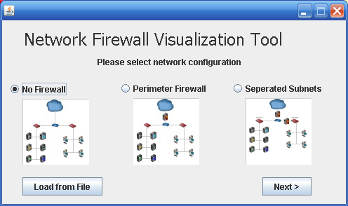

Choose “no firewall” and click next. The following screen will appear:

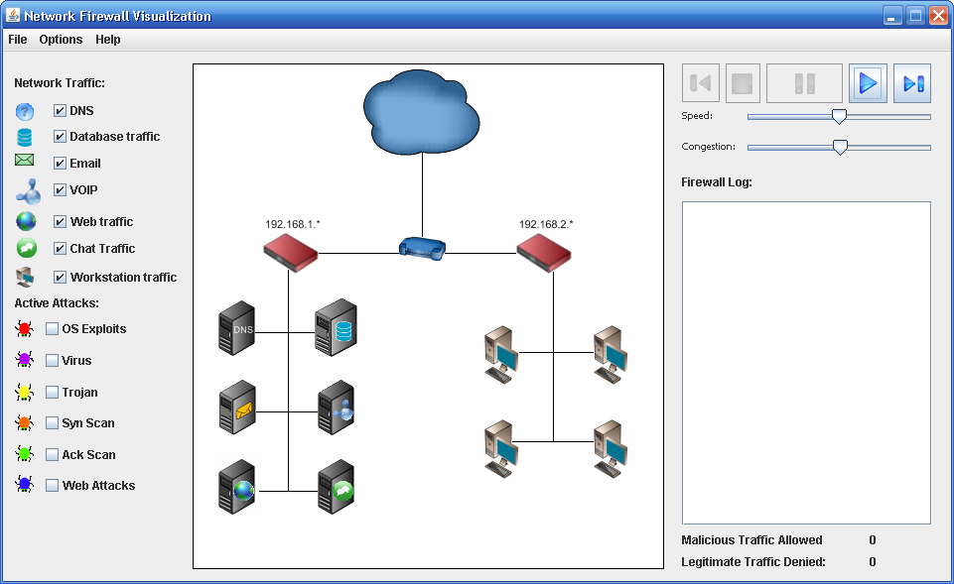

Click the  button. Note that the traffic flows both from the “cloud” or internet to the client machines. By default, there is no malicious traffic flowing to the machines. Click on the *OS Exploit* option. Eventually, you’ll see a similar red colored bug flow from the internet into the local area network and land on a machine, infecting the machine. Once a machine is infected, it is marked as such with the “international No” emblem or  . Let’s see how configuring a firewall will help prevent such infections.

FIREWALL Configuration.

1. Start a new session by clicking File -> New in the upper window of the tool. This time, choose the Parameter firewall. The window that comes up will look like this:

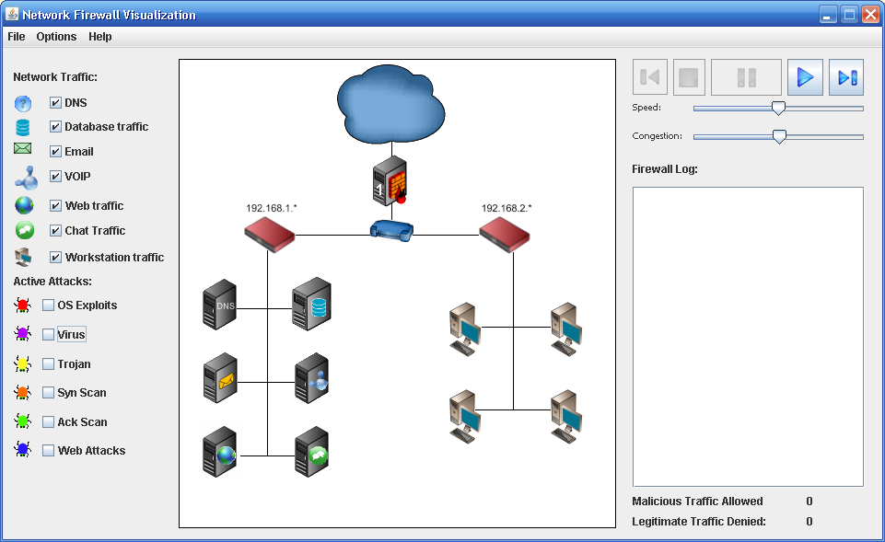

You now have a firewall between the internet (represented by a cloud) and your network router. Click the play button and watch what happens. **Do you see traffic flowing from the internet into your system or from your network to the internet? Explain why or why not:**

1. Add some active attacks by clicking on several different options. **Are these attacks able to get to your network? Do you feel your system is secure? What’s wrong with this scenario?**
2. Configure your firewall to allow traffic to flow in and out of your network. Do this by choosing the ‘options’ tab at the top of the tool and define firewall rules. You should see a screen similar to the one below:

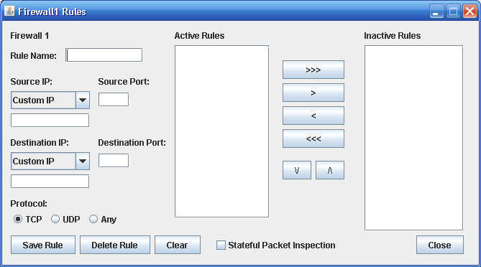

Name your firewall rule (typically with a name that focuses on a given subject or attack). The “Source IP” option and port refer to how you want the firewall to recognize a given source IP/Port combination and respond. The Destination is similar but focusing on a destination rule. The goal of any good firewall configuration is to identify legitimate traffic while restricting malicious traffic. Try setting the following firewall rule:

Rule Name: DNS Rule

Source IP: DNS, Source Port: 53

Destination IP: Any, Destination port *

Protocol: Any.

Click “Save Rule”. You should now see the rule in your Active Rules box. Click “close” and you should be back to your Network Firewall Visualization Tool window. Click the play button and watch what happens. You may need to move the speed bar to the right for a higher speed of traffic. **What traffic now flows through the firewall?** Add some active attacks and watch if they flow through the firewall. **Would you claim your rule is now sufficient to allow traffic to flow for a typical network? Why or why not? Do any of the active attacks now work against machines behind the firewall?**

1. Come up with a series of rules which seems to protect the network from all attacks. Be sure to watch the legitimate traffic denied and malicious traffic permitted in the lower right hand portion of the screen. That should tell you how well your rules are working. **How many rules did you have to write to secure your network? Were you able to completely secure the network? What types of rules did you create?**
2. Download the WorkstationDatabase scenario from the tools page of the web site and save it to your desktop. Choose File -> new to restart the program and click “load from file” button, pointing the program to the file you downloaded.

This scenario was configured so that workstations can pass through *firewall2* and gain access to the database. *Firewall1* has an ***allow all*** traffic rule set so all information is passed through to the network and from the network to the servers. Write rules to prevent active attacks from passing through *firewall 1* and attacking the database. **Which active attacks are you able to prevent by restricting access on the firewall?**

Think back to the class discussion on malicious software attacks and distributed denial of service attacks. **Using the information from that class, why do you think that these types of attacks are not able to be prevented through the firewall? How might you prevent these attacks from taking place?**

Tool Questions:

1. Usefulness of tool:
   1. It helped me to understand the concepts of firewalls
   2. It did not add any additional value to the lecture
   3. I found I was more confused following the use of the tool
2. I found the tool easy to use and configure:
   1. True
   2. False
3. In general, I find such tools:
   1. Helpful in understanding complex topics
   2. Don’t help at all in understanding such complex topics
   3. Neither helpful nor hurtful.
4. General comments and/or suggestions for improving the tool: